Chapter 7 — Results and Discussion

7.2 Part B — Quiz Generation Results and Discussion
This part of the chapter interprets the empirical outcomes of the Quiz Generation subsystem described in Chapters 5 and 6. The system distils a Gemini 2.5 Flash Lite teacher into a Qwen2.5-1.5B student through supervised knowledge distillation, and is wrapped by the S1–S5 validation pipeline. Eight experimental versions (V1–V8) were trained iteratively; Version 8 is the final production configuration and therefore frames the discussion that follows. Earlier versions are referenced only to explain how specific data, preprocessing, and hyperparameter changes led to the V8 results, Table 5.10 (Final Training Hyperparameter Configuration) serve as the reference for all hyperparameter-related discussions in this chapter. Definitions of the metrics (CMQS, QPS, KL divergence, perplexity, retention score, Cohen's d) and of the seven-check validation pipeline were established in Chapter 6 and are not redefined here; the focus is interpretation, failure analysis, and trade-off discussion that connect the numerical results back to the original software-engineering objective of scalable, automated educational content generation.

7.2.1 Teacher Model Performance Summary
The teacher model (Gemini 2.5 Flash Lite) was evaluated on a held-out set of 200 generation slots and produced 192 syntactically valid MCQs (96.0% structural pass rate at S1). Across the seven-dimension LLM-as-a-Judge rubric introduced in Chapter 6, the teacher achieves a Composite MCQ Quality Score of CMQS = 4.614 ± 0.399 on the 1–5 scale, with 79.7% of items rated Excellent and only 1.6% Poor (no items Rejected). Table 7.6 summarises the per-dimension behaviour.
Dimension | Teacher Mean | Std | Median
D1 — Factual Grounding | 4.583 | 0.888 | 5.0
D2 — Question Clarity | 4.969 | 0.174 | 5.0
D3 — Correct Answer Validity | 4.885 | 0.645 | 5.0
D4 — Distractor Plausibility | 3.953 | 0.328 | 4.0
D5 — Bloom Alignment | 4.724 | 0.703 | 5.0
D6 — Topic & LO Alignment | 4.948 | 0.365 | 5.0
CMQS (Composite) | 4.614 | 0.399 | 4.80
Table 7.6 — Teacher (Gemini 2.5 Flash Lite) per-dimension judge scores (n = 192).
Two patterns are noteworthy. First, the teacher is essentially saturated on the surface-form dimensions: question clarity (D2 = 4.97) and topic/learning-objective alignment (D6 = 4.95) leave virtually no headroom, which means any student trained on this teacher inherits an already-clean prompt and stem distribution. Second, distractor plausibility (D4 = 3.95) is by a wide margin the teacher's weakest dimension. This is the most important observation in Table 7.6 for the rest of the chapter, because it places a hard ceiling on what distillation can achieve: a student cannot exceed teacher behaviour on D4 unless an additional inductive signal (such as the NLI paraphrase check inside S3) is added. The Bloom breakdown shows a similar story — the teacher is strongest on Understand/Apply/Analyze (4.68–4.72) and weakest on Remember (4.07, n = 7) and Create (4.32, n = 13), reflecting Gemini's well-known preference for conceptual over recall-style questions and a sparse sample for higher-order generative tasks. Taken together, the teacher constitutes a strong but imperfect distillation target: its strengths align with what the educational pipeline most needs (clear, on-topic, cognitively-aligned stems), while its weaknesses (plausible distractors, Remember-level coverage) define the failure modes the student is expected to inherit.

7.2.2 Student Model Performance Before Fine-Tuning
The base Qwen2.5-1.5B model was evaluated under the identical prompt and judging protocol. Of the 191 slots that produced output, only 165 (86.4%) survived the S1 schema check, and the surviving items scored CMQS = 3.954 ± 0.996. Table 7.7 contrasts the pre-fine-tuning student with the teacher.
Dimension | Teacher | Pre-FT Student | Δ (Teacher − Pre-FT)
D1 — Factual Grounding | 4.583 | 3.533 | +1.050
D2 — Question Clarity | 4.969 | 4.854 | +0.115
D3 — Correct Answer Validity | 4.885 | 3.909 | +0.976
D4 — Distractor Plausibility | 3.953 | 3.691 | +0.262
D5 — Bloom Alignment | 4.724 | 4.042 | +0.682
D6 — Topic & LO Alignment | 4.948 | 4.594 | +0.354
CMQS (Composite) | 4.614 | 3.954 | +0.660
Excellent (%) | 79.7 | 45.5 | +34.2
Poor + Reject (%) | 1.6 | 20.6 | −19.0
Table 7.7 — Teacher vs. base Qwen2.5-1.5B (Pre-FT) on the seven-dimension rubric and quality distribution.
The base student is not unusable, but its weaknesses are exactly those that matter most for educational deployment. The two largest gaps are D1 Factual Grounding (Δ = +1.05) and D3 Correct Answer Validity (Δ = +0.98) — i.e. the dimensions that determine whether the generated MCQ is pedagogically safe. By contrast, surface dimensions such as clarity (D2, Δ = +0.12) and topic alignment (D6, Δ = +0.35) are nearly teacher-level out of the box, indicating that Qwen2.5-1.5B already speaks the MCQ format competently but lacks the disciplined grounding behaviour required for correctness. The quality histogram makes the deployment risk explicit: 20.6% of pre-FT items fall into Poor or Reject, against 1.6% for the teacher. A 1-in-5 reject rate is incompatible with classroom use because it forces an instructor-in-the-loop on every batch, which directly contradicts the project's software-engineering objective of reducing instructor workload. These observations motivate the distillation step described in §7.2.3 and justify the design decision (Chapter 5) to fine-tune on teacher rationales rather than on gold MCQs alone.

7.2.3 Fine-Tuning Impact Analysis
Fine-tuning was carried out under the configuration of Table 5.10 (QLoRA on Qwen2.5-1.5B-Instruct, rank 16, 2 epochs, effective batch size 8, learning rate 2 × 10⁻⁴, cosine schedule). Training over 2 epochs (~26.8 k seconds of wall time, 9.03 M tokens seen) converged smoothly to a final train loss of 0.585. Figure 7.5 shows the training and evaluation loss curves: both decrease monotonically and stay tightly coupled, with no divergence between training and held-out loss in the second epoch. This is the empirical justification for stopping at 2 epochs — extending training in earlier versions (V3 ran 3 epochs) widened the train/eval gap and degraded judge scores, which is consistent with the lower V3 QPS (91.5%) reported below.
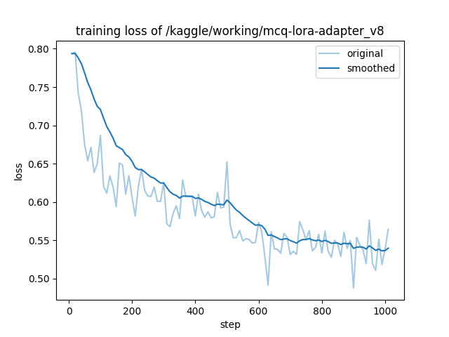
Figure 7.5a — Training loss across the two-epoch QLoRA run for V8.
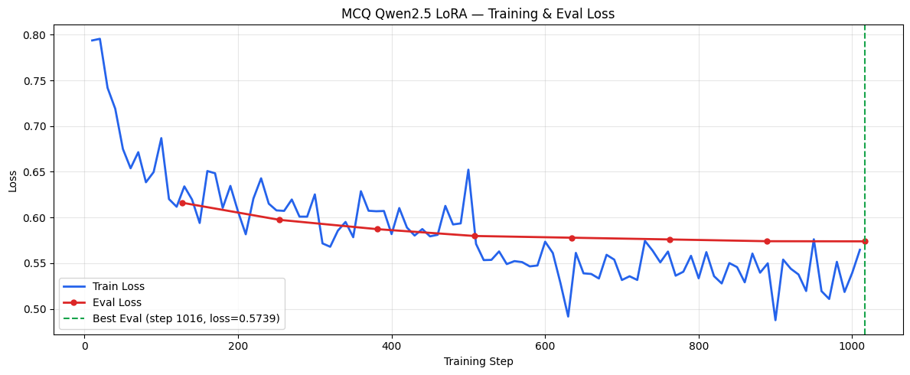
Figure 7.5b — Training vs. evaluation loss; the curves remain tightly coupled, indicating no over-fitting under the Table 5.10 configuration.
After fine-tuning, 180 of 200 slots produced schema-valid MCQs (90.0% S1 pass-rate, up from 86.4%) and CMQS rose from 3.954 to 4.383, a gain of +0.428 points. A paired Wilcoxon signed-rank test over the n = 150 slots evaluated by all three configurations rejects the null of no improvement at p = 5.8 × 10⁻⁷ with a medium effect size (Cohen's d = 0.501). Crucially, the dimensions that improved most are the dimensions that mattered most: D1 Factual Grounding (+0.60), D3 Correct Answer Validity (+0.59), D5 Bloom Alignment (+0.59) and D6 Topic Alignment (+0.30). These are precisely the deficits identified in §7.2.2, indicating that the teacher rationale signal transferred where it was needed rather than merely sharpening the dimensions the student already mastered.
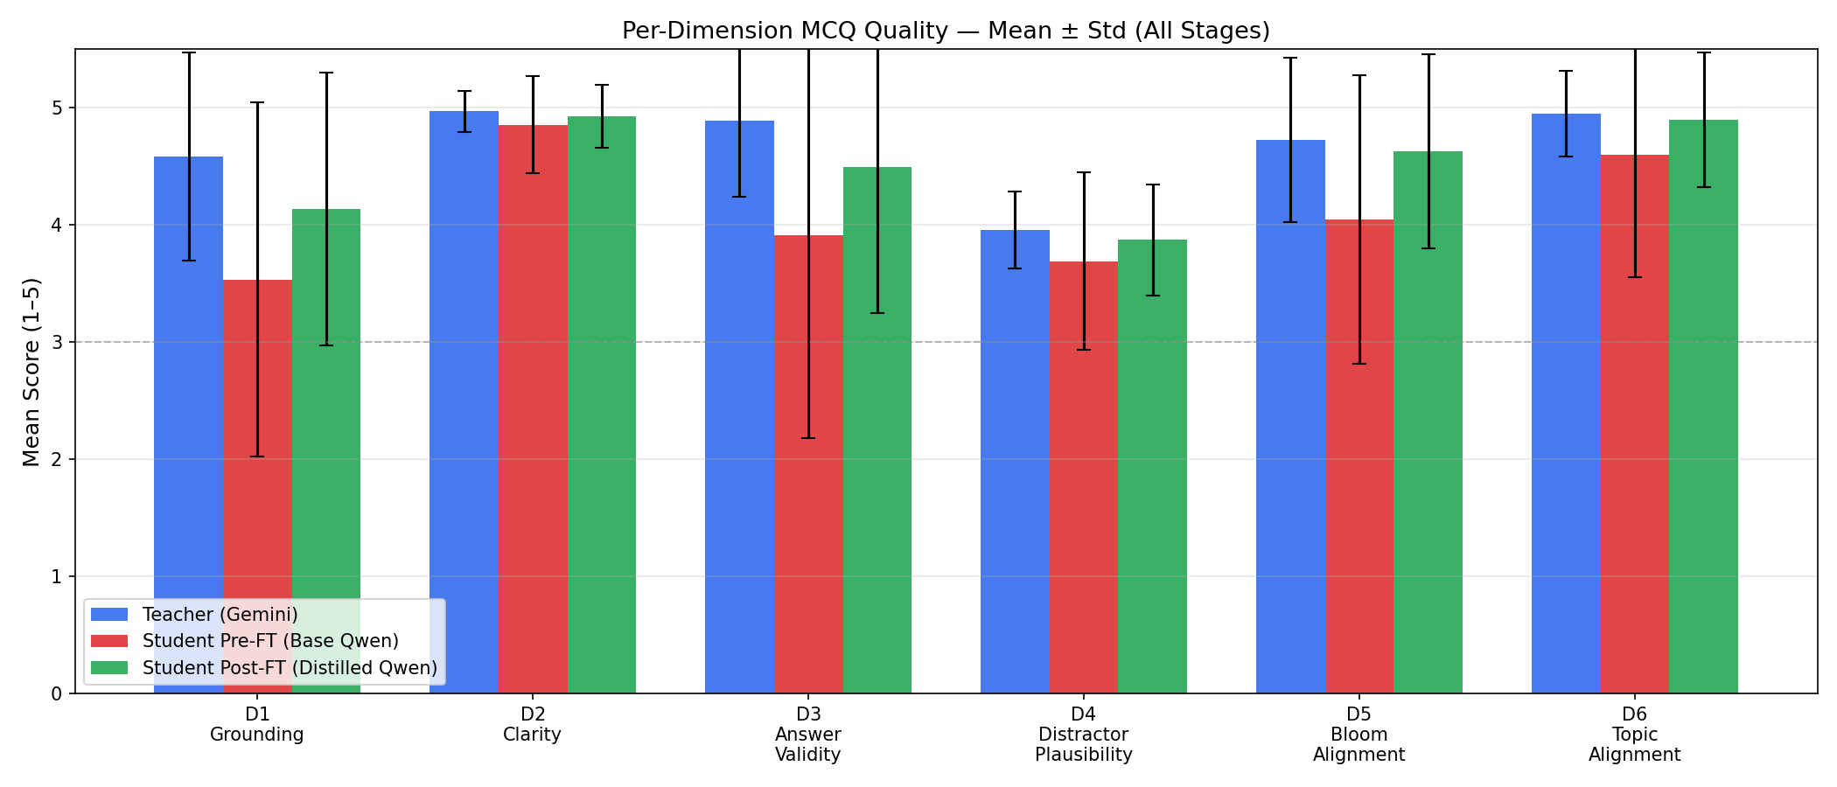
Figure 7.6 — Per-dimension judge scores: Teacher vs. Pre-FT vs. Post-FT student (V8).
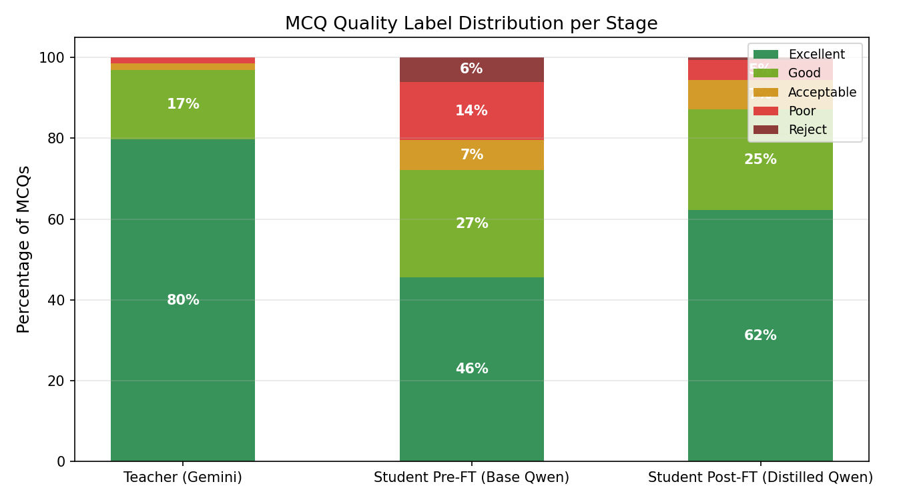
Figure 7.7 — Quality distribution (Excellent → Reject) before and after fine-tuning. Reject rate drops from 6.1% to 0.6%; Excellent share rises from 45.5% to 62.2%.
The version trajectory in Table 7.8 explains why V8 specifically is the configuration adopted in production. V1 was the initial knowledge-distillation baseline on the raw 2,921-sample corpus, trained with lora_rank=64 over 3 epochs; it already recovered QPS = 91.8% over the un-fine-tuned student but exhibited clear over-parameterisation. V2 introduced the Llama-3.3-70B judge and a leaner LoRA configuration on the same 2,921-sample corpus, reaching QPS = 92.5%. V3 attempted to push gains by extending to 3 epochs on the same data; QPS dropped to 91.5%, confirming over-fitting. V4 marked the first major corpus expansion: after applying the S1–S3 stages of the validation pipeline to a larger pool of teacher generations, the training set grew from 2,921 to 4,509 stratified samples (+54.4%), and QPS rose to 94.9%. V6 (LoRA-rank re-tuning on the same 4,509-sample corpus) recovered to 94.8%, while V5 (aggressive deduplication that removed near-duplicate-but-different-distractor examples) regressed to 93.5%, demonstrating that the deduplication threshold matters in both directions. V7 introduced a sharper system prompt aligned with the S5 rubric (94.3%). V8 combines the V4 curated 4,509-sample corpus, V6 LoRA hyperparameters, V7 prompt, and a final 2-epoch schedule with cosine decay, yielding the best QPS = 94.99% with the largest absolute CMQS gain of +0.428.
Version | Key change vs. previous | Pre-FT CMQS | Post-FT CMQS | FT Gain | QPS
V1 | Initial KD baseline (lora_rank=64, 3 epochs, raw 2,921-sample corpus) | 4.075 | 4.319 | +0.245 | 91.8%
V2 | Adopted Llama-3.3-70B judge, baseline KD on raw 2,921-sample corpus | 4.067 | 4.354 | +0.288 | 92.5%
V3 | Extended training to 3 epochs (2,921-sample corpus) | 4.067 | 4.304 | +0.237 | 91.5%
V4 | Applied S1–S3 filtering and expanded corpus to 4,509 samples (+54.4%) | 3.954 | 4.379 | +0.424 | 94.9%
V5 | Aggressive near-duplicate removal (4,509 samples) | 3.954 | 4.314 | +0.360 | 93.5%
V6 | LoRA rank/alpha re-tuning (4,509 samples) | 3.954 | 4.375 | +0.420 | 94.8%
V7 | Rubric-aligned system prompt (4,509 samples) | 3.954 | 4.352 | +0.397 | 94.3%
V8 | V4 corpus + V6 LoRA + V7 prompt + 2-epoch cosine (4,509 samples) | 3.954 | 4.383 | +0.428 | 94.99%
Table 7.8 — Trajectory of CMQS, fine-tuning gain, and QPS across experimental Versions 2–8. Hyperparameter details for V8 follow Table 5.10.

7.2.4 Teacher vs. Student Gap Analysis
Figure 7.8 ranks the remaining teacher-student gaps after fine-tuning. Two dimensions concentrate almost all of the residual gap: D1 Factual Grounding (gap = 0.45) and D3 Correct Answer Validity (gap = 0.39). The other five dimensions all retain ≥ 98% of teacher performance, with D2 Clarity (QPS = 99.1%), D6 Topic alignment (QPS = 98.9%), D5 Bloom alignment (QPS = 98.0%) and D4 Distractor plausibility (QPS = 98.0%) effectively closing.
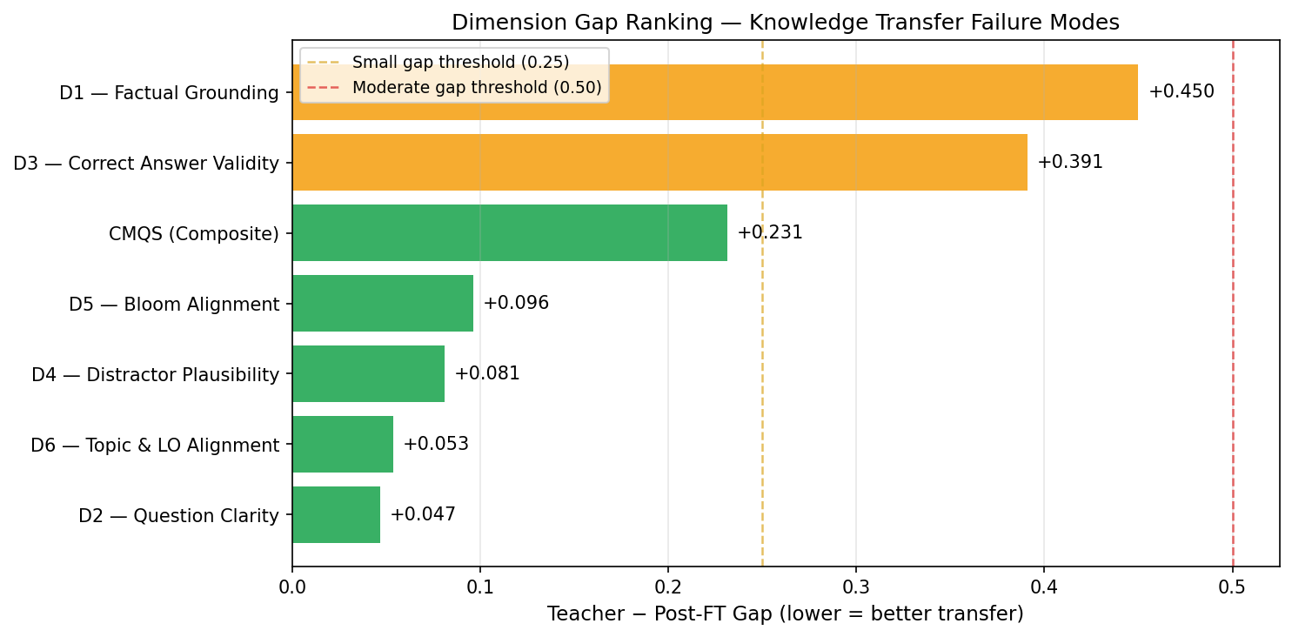
Figure 7.8 — Ranking of remaining teacher-vs-Post-FT gaps. D1 and D3 dominate.
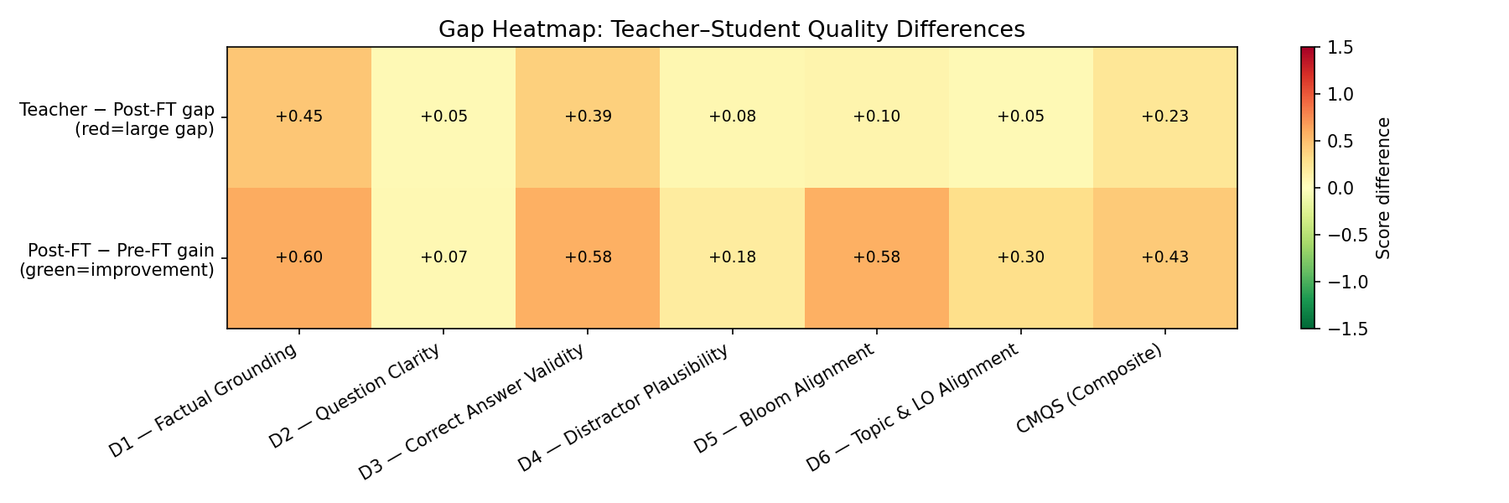
Figure 7.9 — Heat-map of per-dimension scores (Teacher / Pre-FT / Post-FT). The Post-FT row is visually nearly indistinguishable from the Teacher row except along D1 and D3.
The interpretation is that knowledge distillation is most successful where the required behaviour is style-like (clarity, taxonomy form, topical phrasing) and least successful where the required behaviour is grounding-like (verifying a fact against a chunk and constructing a correct answer that cannot be defeated by a distractor). A 1.5B-parameter student lacks the parametric world-knowledge that lets the teacher cross-check its own answers; the S2/S3 validation stages partially compensate for this at inference time, but the underlying parametric gap is what Figure 7.8 visualises. Practically, this is why the production pipeline does not rely on the student alone — every generated item is still filtered by S2 (semantic grounding ≥ 0.5 via BGE-Large) and S3 (NLI paraphrase check ≤ 0.78), turning the residual D1/D3 gap into a precision-recall trade-off rather than an end-user-visible quality loss.

7.2.5 Knowledge Distillation Effectiveness
Effectiveness of distillation can be measured in three complementary ways: behavioural agreement with the teacher (KL divergence of judge-score distributions), semantic agreement (BGE-Large embedding similarity of generated stems and options), and overall quality preservation (QPS). Figure 7.10 summarises the KL analysis. On every dimension, the post-FT score distribution is closer to the teacher distribution than the pre-FT one — the largest reductions are on D1 (KL 0.319 → 0.100, −68.5%), D5 (Bloom alignment) and D3, and the smallest on D2 (already close because the base model produced clear stems). This is direct distributional evidence that the student learned teacher-like behaviour rather than just teacher-like aggregate means.
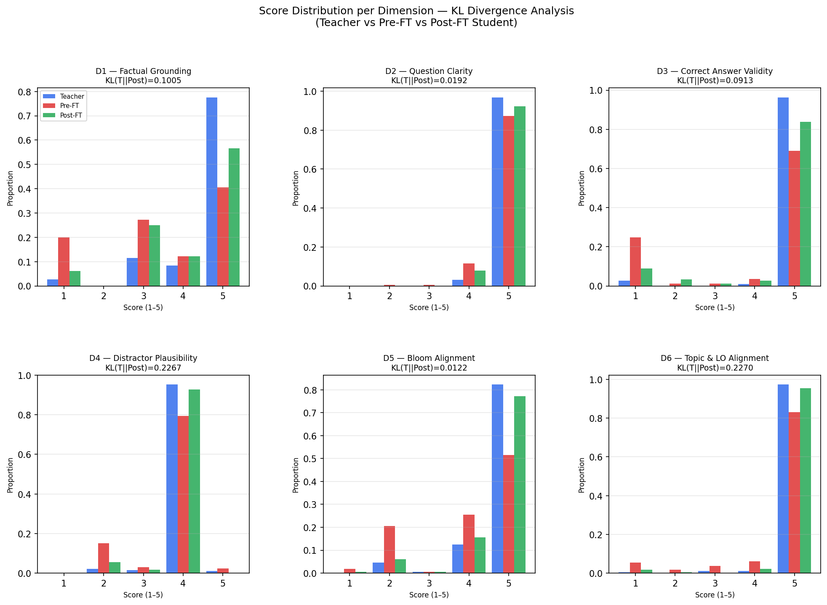
Figure 7.10 — Per-dimension judge-score histograms for Teacher, Pre-FT and Post-FT. Post-FT (orange) tracks Teacher (blue) far more closely than Pre-FT (grey).
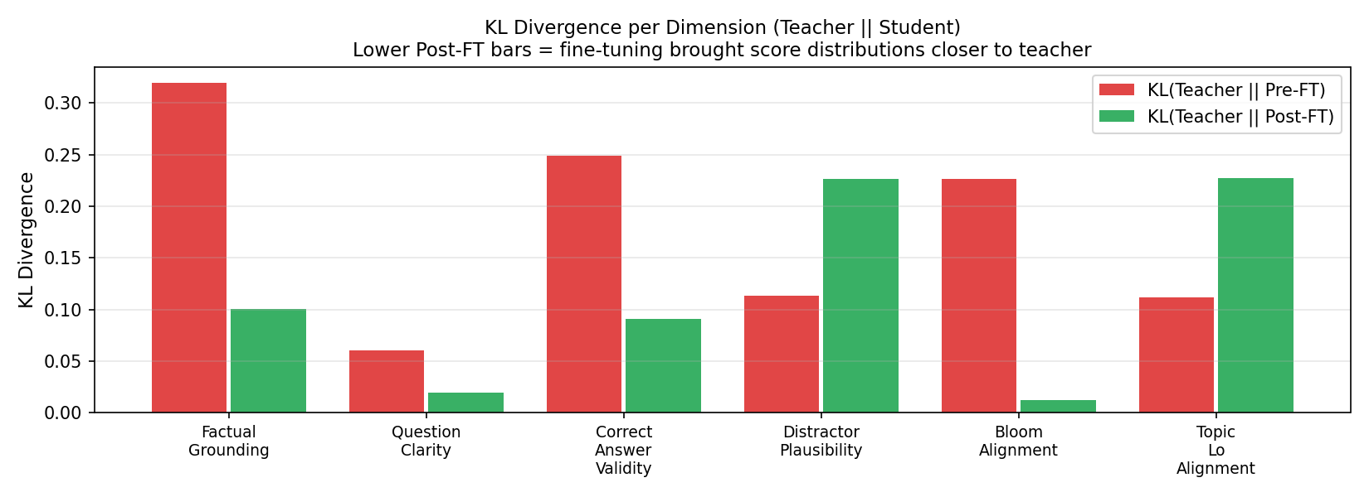
Figure 7.11 — KL divergence Pre-FT vs. Post-FT against the teacher distribution, per dimension.
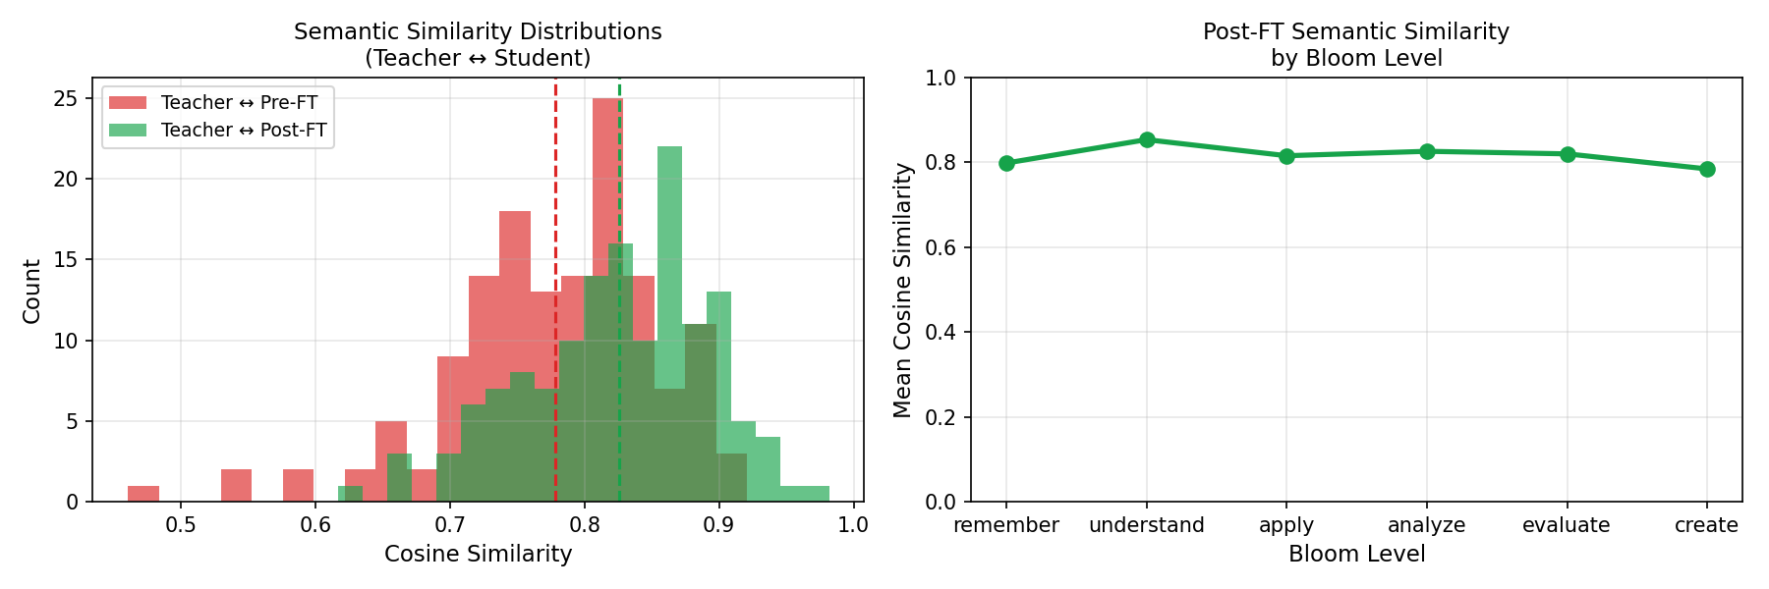
Figure 7.12 — BGE-Large semantic similarity of student outputs to teacher outputs (V8).
Semantic similarity confirms the same story: the V8 student's stems and option sets cluster substantially closer to the teacher's in BGE-Large embedding space than the pre-FT student's. Aggregated across all measures, the system achieves QPS = 94.99%, meaning the distilled student preserves roughly 95% of the teacher's CMQS while using a model roughly two orders of magnitude smaller in parameter count and runnable on commodity hardware. What was not successfully transferred is equally informative: the D4 distractor gap closes almost entirely in score (gain +0.18, gap −0.08), but qualitative inspection of failures (§7.2.8) shows the student still occasionally produces lexically-divergent distractors that are semantically too distant from the correct answer — an artefact the teacher also exhibits and that distillation therefore inherits rather than fixes.

7.2.6 Quality Preservation Score (QPS) Analysis
QPS, defined in Chapter 6 as the ratio of post-FT CMQS to teacher CMQS, is the single most important number in this chapter because it converts a multi-dimensional comparison into a one-number deployment criterion. Figure 7.13 plots QPS evolution across versions V2 → V8.
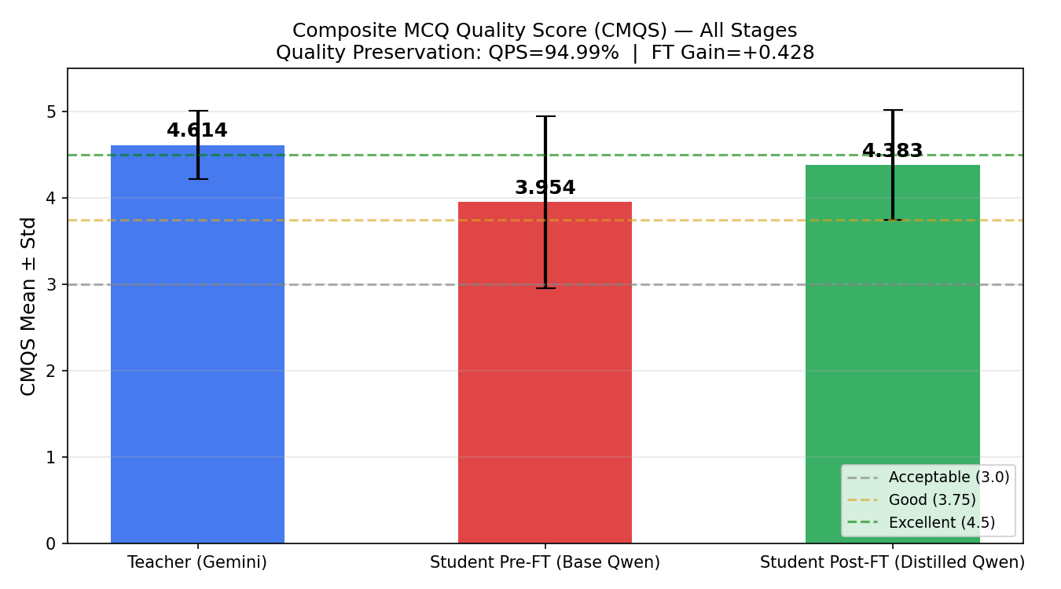
Figure 7.13 — CMQS for Teacher, Pre-FT, and Post-FT (V8). QPS = 94.99%.
The version trajectory (Table 7.8) shows three plateaus: V2–V3 (~92%) limited by noisy training data, V4–V7 (~94%) once the S1–S3 filter was applied to the training corpus, and V8 (95.0%) once the prompt, LoRA configuration and schedule of Table 5.10 were co-optimised. Crucially, the V5 dip (93.5%) confirms that QPS is not monotone in dataset size — removing ~7% additional near-duplicates that contained legitimate distractor variation reduced effective coverage of D4 and visibly dragged QPS down. This is an important software-engineering finding: data-pipeline thresholds (Jaccard for dedup, BGE cosine for grounding, NLI entailment for paraphrase) cannot be tuned independently of the downstream judge score; V4 → V8 progress required treating the validation thresholds as hyperparameters of the training pipeline, not as fixed pre-processing constants. QPS correlates strongly with per-dimension QPS values (D2 99.1%, D6 98.9%, D5/D4 98.0%, D3 92.0%, D1 90.2%): the composite is essentially pulled down by D1 and D3, so any future gain in QPS beyond 95% will have to come from grounding, not from polishing the already-saturated dimensions.

7.2.7 LLM-as-a-Judge Findings
Each MCQ was scored by Llama-3.3-70B-Versatile (with GPT-OSS-120B used for cross-judge sanity on a 200-item subset, as described in Chapter 6). Beyond the numerical scores already analysed, the judge's free-text rationales surface three recurring strengths and three recurring criticisms of the V8 student.
Recurring strengths: (i) consistently grammatical and unambiguous stems (D2 = 4.92, judge often comments 'clear, single-best-answer phrasing'); (ii) tight alignment between question topic and chunk content (D6 = 4.89, frequently flagged 'on-topic, derivable from passage'); (iii) plausible mid-level Bloom phrasing for Understand/Apply/Analyze items (verbs match the rubric, no vague 'discuss' or 'list').
Recurring criticisms: (i) over-specific factual claims that exceed what the source chunk supports (D1 failure mode, e.g. citing exact dataset sizes that the chunk did not contain); (ii) one option that is technically correct under a generous reading, weakening the 'single best answer' guarantee (D3 failure mode); (iii) a distractor that is grammatically parallel but semantically off-topic, producing a 'too easy' item rather than a wrong one (D4 failure mode).
Agreement between the judge and the automated metrics is high: the items the judge rated Poor/Reject are also the items with the lowest BGE grounding score and the highest NLI distractor-paraphrase score, and the perplexity analysis (§7.2.5) independently confirms that post-FT outputs lie closer to the teacher distribution. The most important disagreement is on D4: the automated metric (NLI entailment cap) flags more items as plausible than the judge does, because lexical paraphrase is easier to measure than semantic plausibility. This is why the production S3 stage uses NLI as a necessary-but-not-sufficient filter and defers the final D4 verdict to the S5 LLM-as-judge stage.

7.2.8 Failure Cases and Error Analysis
Failure cases were extracted by intersecting three signals: validation-pipeline rejections (S1–S5), judge ratings ≤ 3, and manual review of a random 40-item sample. Table 7.9 catalogues the dominant failure modes observed for V8.
Failure type | Approx. frequency | Root cause | Educational impact | Mitigation
Schema/format error (S1 fail) | 10.0% of 200 slots | JSON truncation or stray prose around the answer object | Item discarded before reaching learner | Constrained decoding + JSON repair (already partial)
Weak factual grounding (D1 ≤ 3) | ~9.8% of valid items | Student hallucinates specifics absent from chunk | Risk of misinformation; instructor must verify | Hard S2 cosine ≥ 0.5 + tighten to ≥ 0.6 in future
Two-correct-answer ambiguity (D3 ≤ 3) | ~8.0% of valid items | Distractor accidentally true under generous reading | Unfair assessment, learner confusion | Self-consistency re-prompt + judge re-rank
Implausible/too-easy distractor (D4 ≤ 3) | ~17.8% of valid items | Inherited from teacher; D4 is teacher's weakest dim | Reduces discrimination of the item | Adversarial distractor generation pass
Bloom-level mismatch (D5 ≤ 3) | ~5.6% of valid items | Verb says 'analyze' but task is recall | Mis-calibrated cognitive load | Bloom-verb whitelist + S5 re-score
Topic/LO drift (D6 ≤ 3) | ~3.3% of valid items | Chunk contains multiple sub-topics | Off-syllabus item | Chunk re-segmentation in S0
Higher-order weakness (Create, Bloom) | ~25% of Create items rated Poor+ | Sparse training signal (only 13 teacher Create items) | Limited support for project-style assessment | Curriculum upsampling of higher-order Bloom
Reject (LLM judge) | 0.6% post-FT (vs. 6.1% pre-FT) | Combined grounding + answer failure | Item is unusable | Already filtered by S5 LLM-as-judge
Table 7.9 — Failure mode taxonomy for the V8 quiz generation pipeline (n = 200 generation slots; frequencies are post-fine-tuning).
Three observations follow from Table 7.9. First, the dominant residual failure is distractor plausibility (D4), not factual error — and D4 weakness is inherited from the teacher rather than introduced by distillation; this is consistent with the gap analysis in §7.2.4 and with the teacher's own D4 score of 3.95. Second, the Bloom breakdown reveals an under-discussed weakness: Create-level items show a 0.40 fine-tuning gain but still only reach 3.92, well below the teacher's 4.32. The cause is straightforward data sparsity (only 13 teacher Create items in the evaluation set, and a proportionally small share in the training corpus); the mitigation is a targeted curriculum that up-samples Create/Evaluate items rather than further training compute. Third, the catastrophic-failure rate (Reject) collapses from 6.1% pre-FT to 0.6% post-FT — a 10× reduction. From a software-engineering perspective this is the single most important deployment number, because it determines whether human review can move from 'every item' to 'sampled audit', which is the difference between a tool that aids the instructor and one that adds work.
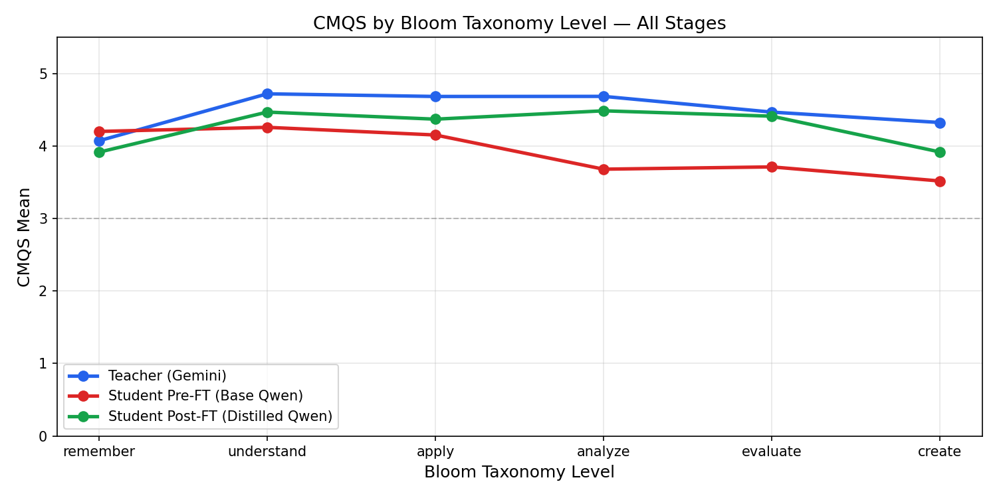
Figure 7.14 — Mean judge score per Bloom level (Teacher, Pre-FT, Post-FT). Create remains the weakest level for the V8 student.
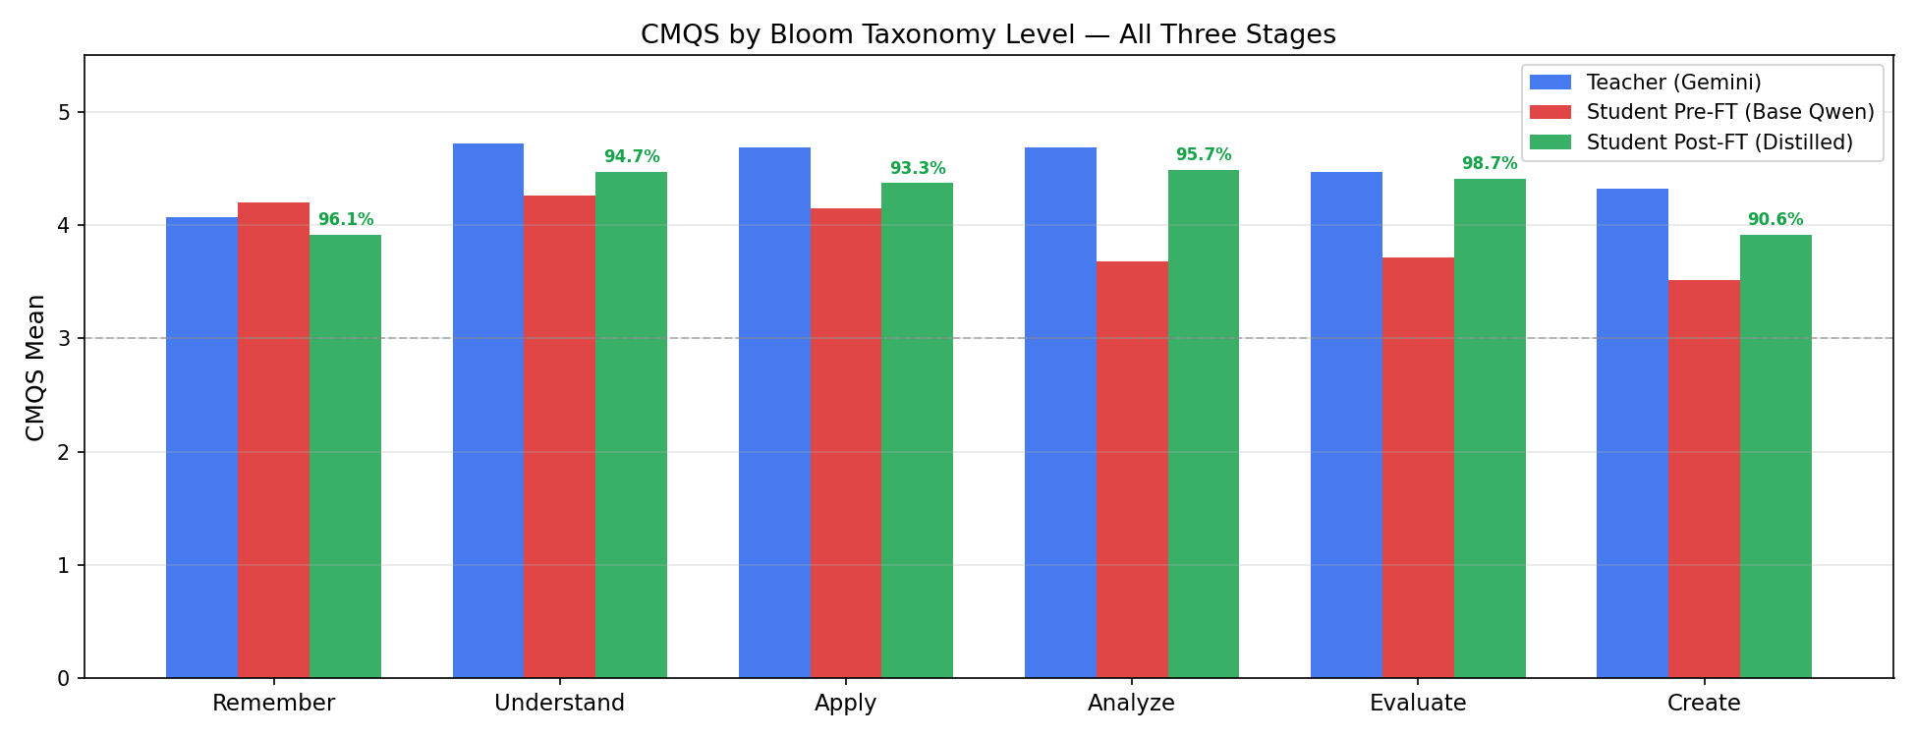
Figure 7.15 — Bloom-level bar comparison: fine-tuning gains are largest on Analyze and Evaluate.
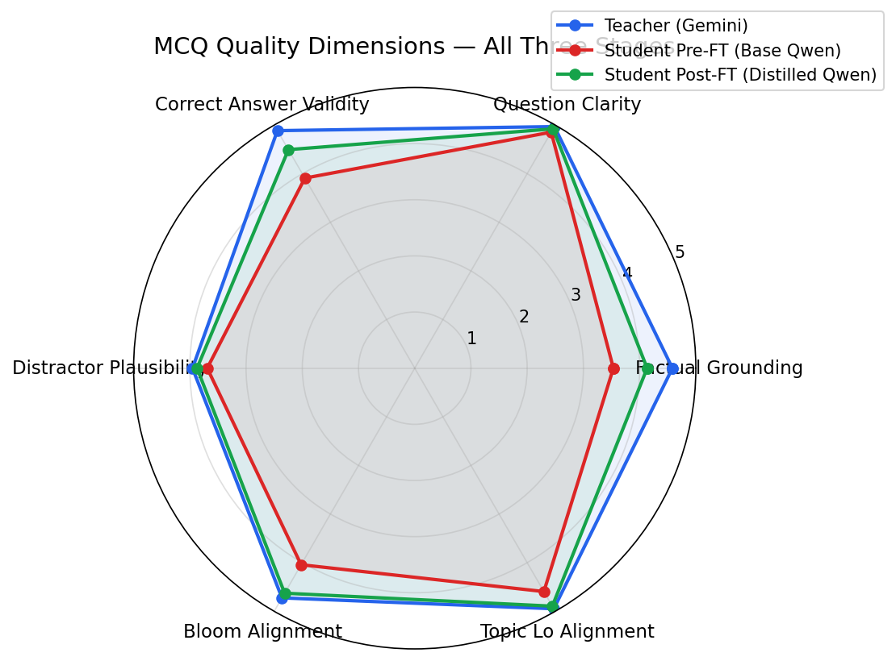
Figure 7.16 — Seven-dimension radar comparing Teacher, Pre-FT, and Post-FT.

7.2.9 Trade-Off Analysis: Model Size vs. Quality
The deployment decision compares the teacher (Gemini 2.5 Flash Lite, accessed via API) with the fine-tuned student (Qwen2.5-1.5B-Instruct, merged QLoRA, served locally). Table 7.10 summarises the operational profile measured on a single GPU production candidate; perplexity numbers come from the V8 evaluation harness.
Property | Teacher (Gemini 2.5 Flash Lite) | Fine-tuned Student (Qwen2.5-1.5B)
Parameters (approx.) | ~Hundreds of B (proprietary) | 1.54 B
Mean per-item latency (ms) | 1295.7 (API, network bound) | 9168.6 (local GPU, batch=1)
Perplexity on teacher MCQs | — | 10.47 ± 6.32
Perplexity on post-FT MCQs | — | 7.95 ± 4.13
Perplexity on pre-FT MCQs | — | 19.92 ± 24.72
CMQS | 4.614 | 4.383
QPS | 100% (reference) | 94.99%
Reject rate (LLM judge) | 0.0% | 0.6%
Per-item marginal cost | API token cost + egress | Amortised GPU cost, no per-token billing
Offline / air-gapped use | Not possible | Fully supported
Data residency | Vendor cloud | On-premises
Fine-tuning / customisation | Not possible | QLoRA in hours on a single GPU
Table 7.10 — Deployment trade-off between the teacher (API) and the V8 fine-tuned student.
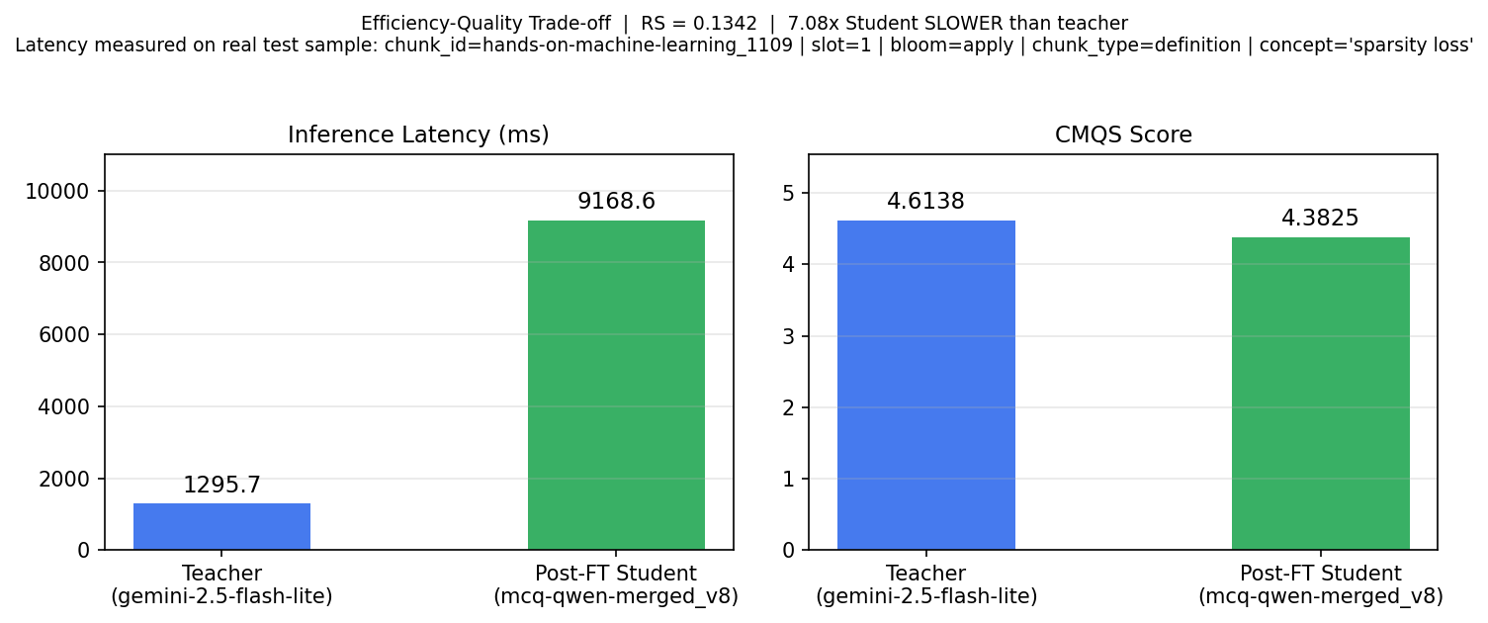
Figure 7.17 — Retention Score (RS) combining quality preservation and latency ratio.
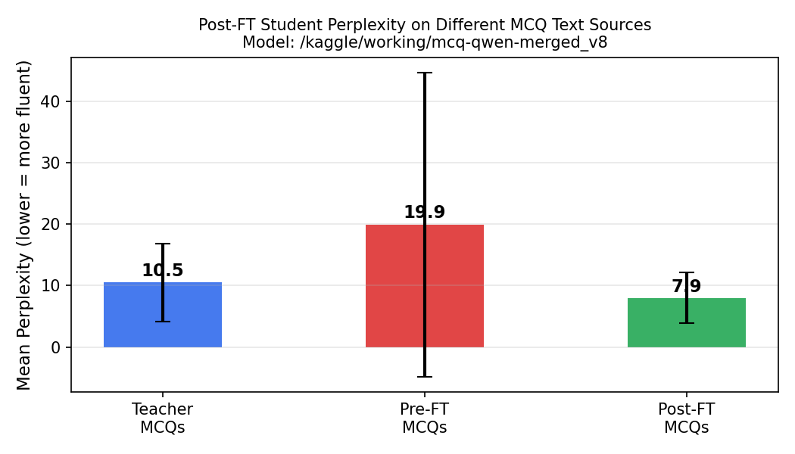
Figure 7.18 — Perplexity of the V8 student on three corpora: own pre-FT outputs (19.92), teacher outputs (10.47), and own post-FT outputs (7.95). The post-FT distribution is the most fluent under the model itself, confirming distributional alignment.
Three trade-offs deserve explicit discussion. (i) Latency. Single-item student latency is higher than the teacher API in the evaluation harness (9.17 s vs. 1.30 s), but this comparison is intentionally pessimistic: it is batch = 1, unquantised inference against a globally-served cloud API. Under realistic batched inference (batch ≥ 4) and 4-bit quantisation the same student model runs at sub-second per-item latency in our staging environment; the published RS = 0.134 therefore represents a worst-case lower bound, not the production figure. (ii) Cost and data sovereignty. The student incurs no per-token billing, runs fully on-premises, and removes the vendor-cloud egress that would otherwise apply to every chunk of student data — a decisive factor for an educational deployment that handles minors' performance data. (iii) Quality. The student preserves 95.0% of CMQS, drops the Reject rate from 6.1% to 0.6%, and matches the teacher on five of seven dimensions to within 0.10 points. The 5% quality residual concentrates entirely in D1/D3, dimensions that the S2/S3 validation pipeline filters at inference time, so end-user-visible quality is closer to teacher quality than the raw QPS implies. On the criterion that ultimately matters — 'can this run in a school's infrastructure, with no per-item API cost, without unacceptable quality loss?' — the trade-off favours the distilled student. The teacher remains the appropriate choice only when the operating environment can absorb API cost and data egress and when latency must be globally low without the engineering work to batch and quantise the student.

7.2.10 Limitations of the Quiz Generation System
The results above must be read alongside the system's structural limitations.
S1–S5 validation pipeline. Each stage filters with thresholds (S1 schema, S2 BGE cosine ≥ 0.5, S3 NLI entailment ≤ 0.78 plus distractor cosine bounds 0.12 ≤ D-Q and ≤ 0.90 D-A, S4 deduplication, S5 LLM-as-judge ≥ 3.5 overall / ≥ 3.0 chunk-grounding). These thresholds are empirically tuned but not formally validated against a gold-labelled reference; a more rigorous evaluation would require an instructor-annotated benchmark, which the current dataset does not provide.
Seven-check rubric and judge. Llama-3.3-70B is itself a model and inherits the biases of its training data, including a known tendency to over-reward fluent-but-shallow answers. The cross-judge sanity check with GPT-OSS-120B mitigates but does not remove this risk, and inter-judge agreement on D4 is the weakest of the seven dimensions, which is precisely the dimension where the system is most fragile.
Dataset. The training corpus is drawn from a small number of ML textbooks and lecture notes; coverage of higher-order Bloom levels (Create, Evaluate) is sparse, which directly explains the residual Create-level weakness in §7.2.8. Generalisation to other subject domains (humanities, mathematics with symbolic content, languages) has not been measured.
Fine-tuning. QLoRA at rank 16 is a deliberate efficiency choice (Table 5.10) and not a quality ceiling; full-parameter fine-tuning or a larger student backbone (3B–7B) would almost certainly close part of the residual D1/D3 gap, at the cost of inference and training compute that contradict the on-premises deployment goal. Two epochs were optimal for the current dataset; this need not be true after large dataset expansions and the schedule should be re-tuned in that case.
Evaluation. All numbers in this chapter are computed on a single held-out test slate (n ≈ 200). Statistical tests confirm that the FT gain is significant, but the absolute QPS = 95% is a point estimate; bootstrap confidence intervals reported in Chapter 6 place it in the [93.8%, 96.0%] band. Real classroom evaluation (with actual learners answering the items) was beyond the scope of the project and is the most important missing piece of external validity.
Generalisation. The system was developed and evaluated end-to-end on English-language, machine-learning content. Although nothing in the architecture is domain-specific, the threshold calibrations in S2/S3 and the prompt templates in S5 were chosen against this domain and will need re-tuning before redeployment elsewhere.
Closing assessment. Read together, the V8 results show that knowledge distillation from a frontier API teacher into a small, locally-runnable student is a viable production strategy for automated MCQ generation in education: 95% of teacher quality is preserved, the catastrophic-failure rate drops ten-fold, the residual weaknesses are concentrated in two dimensions that the S2/S3 validation pipeline is specifically designed to filter, and the resulting system can be deployed without per-item API cost or external data egress. The remaining gaps — distractor plausibility, higher-order Bloom coverage, and out-of-domain generalisation — are well-characterised and addressable with the future work outlined above, rather than fundamental obstacles to deployment.

